MS.NET
Mini Project
School Management System
(SMS)

Copyright © 2011 iGATE Corporation. All rights reserved. No part of this publication shall be reproduced in any way, including but not limited to photocopy, photographic, magnetic, or other record, without the prior written permission of iGATE Corporation.
IGATE Corporation considers information included in this document to be Confidential and Proprietary.

Document Revision History

Date | Revision No. | Author | Summary of Changes
20th September 2017 |  | Vijay Vishwakarma | Initial draft

Table of Contents
Introduction 4
Setup Checklist 4
Instructions 4
Problem Statement 5
Objective 5
Abstract of the project 5
Functional components of the project 6
Technology used: 7
Implementation 8
Summary of the functionality to be built: 8
Guidelines on the functionality to be built: 9

Introduction

This document outlines a mini project for the .NET Line of Technology (LOT). The project is to develop online School Management System Application. This document contains the requirements, work flow of the system and gives guidelines on how to build the functionality gradually in each of the course modules of the .NET LOT.

Setup Checklist
Minimum System Requirements
- Intel Pentium 4 and above Windows XP, 2000 and 2003
- Memory 1 GB
- Internet Explorer 6.0 or higher
- SQL Server 2012 client and access to SQL Server 2012 server
- Visual Studio 2013

Instructions
- The code modules in the mini project should follow all the coding standards.
- Create a directory by your name in drive <drive>. In this directory, create a subdirectory MiniProject. Store your Project here.
- You can refer to your course material.
- You may also look up the help provided in the MSDN
- Since this project work will span over couple of months, you will need to take care of maintaining the code

Problem Statement

Objective

Development of Online School Management System (SMS)
Abstract of the project

Shiksha education society wants an Online School Management System for managing and performing day to day school activities. The application should be able to maintain Student details, Teacher details, Student Attendance and Fees payment. It should also generate reports like student attendance, fees payment etc.

This system will have three user i.e. Administrator, Teacher and Cashier

Role of Administrator:-
- Managing Student Details
- Managing Grade Details
- Managing Teacher Details
- Assigning Teacher to Class
- Creating and managing user
- Generating reports

Role of Teacher:-
- Marking Student attendance
- Updating Teacher details

Role of Cashier:-
- Updating Student fees payment
- Creating Invoice for fees payment
- Generating report for pending fees based on class

Functional components of the project
Application Architecture:
Distributed web applications traditionally to be designed and built across three logical tiers:
- Database Access Layer (DAL)
- Business Logic Layer (BLL)
- Presentation Layer

The DAL refers to the database itself, the stored procedures, and the component that provides an interface to the database. The BLL refers to the component that encapsulates all the business logic of the application. And, the Presentation layer refers to the web application pages.

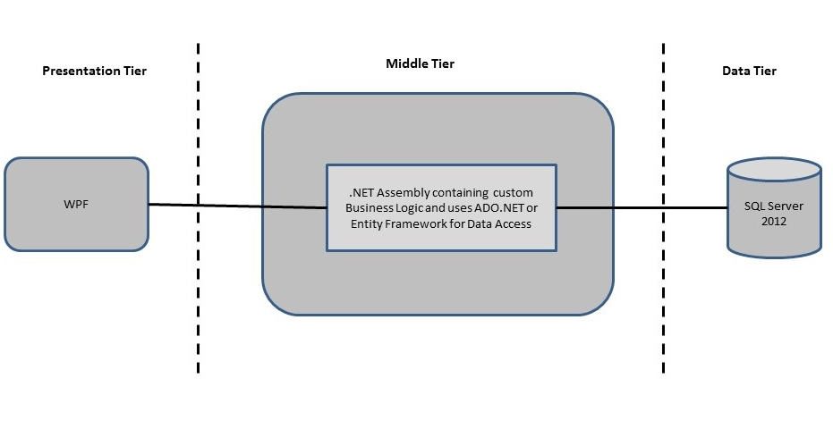

Design guidelines
- All the exceptions/errors to be captured and user friendly message to be displayed on the CommonError page.
- Data access layer of 3-tier useADO.NET data access using SQL stored procedures - All the database interaction would be performed using Data Access Component. Most common methods in Data Access Component would be –
- Create Connection to the Database
- Create Command Object
- Set Command Type to Stored Procedure
- Create and Populate Parameters
- Execute the Command
- Close the Connection

Technology used:
    - Presentation Layer
      - WPF 4.5

    - Business Layer
      - Business Logic Components and Services :-
        - C# 5.0

    - Database Layer
      - Databases:-
        - SQL Server 2012

Sr. No | Course | Duration | Functionality to be built
Sr. No | Course | (in PDs) | Functionality to be built
1 | MS SQL Server 2012 | 4 | Creating relevant database tables and stored procedures
2 | NET Framework 4.5 + C# 5.0 | 7.5 | Developing Business components (C# classes)
3 | ADO.NET 4.5 | 3 | Integrating the DAL and BLL And PL
4 | LINQ and Entity Framework | 2 | Creating data model and data context and Using LINQ to Entities
5 | WPF 4.5 | 2 | Incorporating advanced UI functionality with WPF 4.5
6 | Mini Project Presentation | 1 | The Mini Project Presentation day

Note: Saturday half day will be devoted for mini project

Implementation

Summary of the functionality to be built:
The participants need to develop the Payroll and Time Management System by building the functionality incrementally in each of the course modules of .NET LOT.

Guidelines on the functionality to be built:

The functionality and components to be built in each of the course modules of .NET LOT is as follows:

- Course: SQL Server 2012

Create Data Model - identify the different tables and fields that we will need, which would later be used for building the rest of the application.

Database Schema - Taking these objects, we can easily identify our main tables in the database.

- Grade :- Grade ID, Grade Name, Description
- Teacher :- Teacher ID, Name, Gender, DOB, Contact, Email, Address
- Student :- StudentId, Student Name, Gender, DOB, Blood Group, Contact, Address
- Attendance :- Attendance ID, Student ID, Date, Attended
- Fees :- Invoice ID, Payment date, Student ID, Fees Amount

- Course: WPF 4.5
- Develop the prototypes for following functionalities
- Login page : This page will allows user to provide their login credential for authentication
- Home Page : This page will provide details based on the user
- Maintain Teacher Page :- This Page will admin to maintain teachers details
- Maintain Student Page :- This Page will allow admin to maintain student details
- Maintain Grade Page :- This Page will allow admin to maintain grade details
- Attendance Page :- This page will allow teachers to mark student attendance
- Fees Payment Page :- This page will allow cashier to perform fees related activites

b. In this course you need to develop the user interface using WPF. The screens should include the fields as per the functionality mentioned above. Include Validations where ever required

3.Course: C# 5.0 and ADO.NET 4.5
  - Develop business component (C# classes) for the above functionality.

- Grade Class :- This class will contain methods for managing Grade information
- Teacher Class :- This class will contain methods for managing Teachers information
- Student Class :- This class will contain methods for managing Student information
- Attendance :- This class will contain methods for managing attendance information
- Fees Class :- This class will contain methods for managing fees information

You need to create Layered Architecture which comprises of PresentationLayer (WPF),Business Logic Layer (C# Classes) and DAL Layer(Using ADO.Net 4.5 or Linq and Entity Framework)

DAL Layer of ADO.NET 4.5 will include all the required code snippets for CRUD Operations.

All the CRUD operations should use SQL Server Stored Procedures(For Insert,Update,Delete & Search).

The connectionString should be stored in the configuration file only.

OR

4.Course : LINQ and EF
- Using the Code First Approach of Entity Framework creating the following entites and DataContext Class for performing CRUD Operations.

- Grade Class :- This class/entity will hold Grade information
ii. Teacher Class :- This class/entity will hold Teacher information
iii. Student Class :- This class/entity will hold Student information
iv. Attendance Class :- This class/entity will hold Attendance information
v . Fees Class :- This class/entity will hold fees information

Create a Datacontext class to implement Entity sets and Implement the required business logic using LINQ (like retrieving data, sorting data, searching data etc).

- Course: ADO.NET 4.5 and WPF 4.5
  - Integrate all screens (WPF ) with business components (C# classes) to complete the entire functionality.

Project Evaluation Guidelines
The project it is to be evaluated based on the following five parameters:

- Proper Database Structure and UI designing as per the specifications –(15 Marks)
  - Proper Database Design and Stored Procedure
  - Visual look and feel of the UI
- Project Completion – (20 Marks)
  - Timely Completion of the project
  - Integration of all component of the system
- Defect free execution – (30 Marks)
  - Error free execution of individual modules and the whole system
  - Validation
  - Functionality as per the specified requirements
- Compliance of standard and guidelines – (15 Marks)
  - Appropriate comments entries
  - Adherence to naming conventions for classes, functions, variables and files
  - Simplicity of user interface and screen layouts
  - Maintainability of codes (for example, no one function should be more than 100 lines)
- Group Presentation and Query handling – (20 Marks)
  - Participants (Group of 3 to 4) to present the project with UML Diagrams(use case diagram and one of the sequence or activity diagram) and PPT

